WEST RIDGE ELEMENTARY PTO
MEETING AGENDA
Date: Oct. 3, 2012 | Time: 6:30 – 8 p.m. |  |  | Location: West Ridge Elementary School Cafeteria
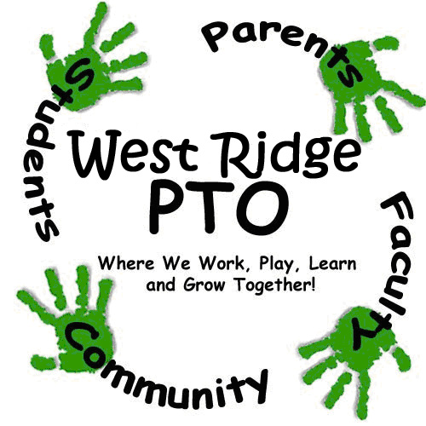Purpose: Regular PTO meeting |  |  | Code of Conduct: Standard Code of Conduct
Facilitator: L. Hadaway |  | Scribe: L. Alston |  |  | Timekeeper: J. Liu/G.Hurt
Agenda:
Welcome, Introductions |  |  | Leah Hadaway |  |  | 5 minutes
Old Business  - Fall Fundraiser Update  - Spirit Nights Sept.- Sonic and Skate City  - Donation to Brantner PTO |  |  | Leah Hadaway  Jennifer Liu |  |  | 10 minutes  5 minutes
New Business  - Read, Run, Roar! Event Oct. 12  -Limo Driver?  -Reader Volunteers  - Trunk or Treat- Oct. 26th  -Fazoli’s Spaghetti Night  -Other fun activities?  - Ongoing Fundraising  -Summer Collection Contest Winner  -Need new Labels for Education Coordin.  -Treasure Chest- volunteers and donations  - Hospitality Update-Teacher Conferences  - Budget Update  - Spirit Nights  -Oct. 9th Cici’s Pizza- 5pm-8pm  -Oct 24th Yogurt Yum- All Day Long  - Communications Update  -VolunteerSpot  - Bulletin Board Volunteers |  |  | Leah Hadaway  Lindley Alston  Kristi King/Chris Neely  Jennifer Liu  Lindley Alston |  |  | 15 minutes  10 minutes  5 minutes  5 minutes  5 minutes
Summary, Questions and Participant Feedback |  |  | Leah Hadaway |  |  | 5 minutes
Committee Break-Out – Activities/Fundraising  - Committees may stay and address any topics needed or they may schedule another time to meet. |  |  | Leah Hadaway |  |  | 20 minutes
Adjourn
NOTES:

